Fooditude: A Community-Driven Mobile Application for Hyper-Local Food Waste Reduction

Course: CSIS 4495 - Applied Research Project, Section 001
Student: Frederick K. Okornoe (300373397)
Date: December 2025

Contents
1. Introduction 2
2. Proposed Research Project 2
3. Project Planning and Timeline 3
4. Implemented Feature 1: Cross-Platform Mobile Architecture 4
5. Implemented Feature 2: Core Food Sharing Ecosystem 6
6. Implemented Feature 3: Community Trust and Communication Infrastructure 7
7. Implemented Feature 4: Administration and Platform Moderation 9
8. Reflections and Lessons Learned 10
9. Concluding Remarks 11
10. References 12
11. Appendix A: Installation Guide 13
12. Appendix B: User Guide 13
13. Appendix C: System Architecture and Technology Stack 14
14. Appendix D: API Endpoint Documentation 15
15. Appendix E: Code Explanation 18

1. Introduction
Food waste represents one of the most significant environmental and social challenges of our time, with approximately 1.3 billion tons of food lost or wasted globally each year according to the United Nations Food and Agriculture Organization. While large-scale initiatives address commercial food surplus, household-level food waste remains largely unaddressed by existing technological solutions. This research project addresses this critical gap through the development of Fooditude, a community-driven mobile application designed to facilitate hyper-local food sharing among neighbors and community members.
The project emerged from recognizing that individuals frequently possess surplus food from various circumstances over-purchasing, garden abundance, or unexpected travel plans yet lack convenient mechanisms to connect with nearby community members who could benefit from these resources. Fooditude bridges this gap by creating a digital platform that enables peer-to-peer food sharing within defined local communities, thereby reducing waste while fostering community engagement and addressing food insecurity at the neighborhood level.
This final report documents the complete research and development process, from initial proposal through implementation, testing, and validation of the functional prototype. The project demonstrates how applied computer science research can create tangible solutions to real-world environmental and social challenges through thoughtful system design and user-centered development methodologies.

2. Proposed Research Project
The primary objective of this applied research project was to design, develop, and validate a functional prototype of the Fooditude platform that enables efficient food sharing within local communities. The project was guided by three core research objectives that structured the development and evaluation process throughout the semester.
First, the design and development objective focused on creating an intuitive, mobile-first application incorporating essential modules for user profiles, food listing, discovery mechanisms, claiming functionality, and communication tools. This objective required careful consideration of user experience design principles, particularly given the time-sensitive nature of food sharing and the importance of building trust within community contexts.
Second, the pilot study objective involved deploying the functional prototype within a targeted community environment to assess usability, functionality, and user engagement patterns. This component was essential for moving beyond theoretical design to practical implementation, allowing for real-world validation of the platform's core assumptions about user behavior and community dynamics.
Third, the data collection and analysis objective centered on gathering both quantitative platform usage metrics and qualitative user feedback to evaluate the platform's effectiveness in changing food-sharing behaviors and reducing household waste. This mixed-methods approach provided comprehensive insights into both behavioral outcomes and user experiences.
The research hypothesis guiding this project posited that a user-friendly, community-driven digital platform would significantly increase successful food sharing and subsequently reduce household food waste within defined communities by making the exchange process convenient, reliable, and socially rewarding. This hypothesis was tested through the implementation of key platform features and subsequent user engagement analysis.

3. Project Planning and Timeline
The project adhered to an Agile development methodology, allowing for iterative improvements and responsive adaptation to emerging challenges and opportunities throughout the development lifecycle. This approach proved particularly valuable when a significant strategic pivot was identified as necessary during the initial development phase.
The project timeline was structured across three distinct phases, each with specific deliverables and evaluation criteria. Phase 1, encompassing research and planning, was completed between September and October 2025 and included comprehensive literature review, requirement analysis, and architectural design. This foundation proved crucial for informing subsequent development decisions and ensuring alignment with both technical requirements and user needs.
Phase 2, focused on development, represented the most intensive period of project activity. Initially, development commenced with a mobile-responsive web application using React.js; however, user research and analysis of successful sharing economy platforms revealed that native mobile applications offered superior user experiences for location-based, on-the-go interactions. Consequently, a strategic pivot to React Native was implemented, enabling true cross-platform mobile development while maintaining development efficiency through code reuse.
This development phase saw the implementation of all core platform modules, including user authentication, food listing and discovery, real-time claiming system, and in-app messaging. Each module underwent iterative refinement based on continuous testing and emerging user requirements. The midterm report documented substantial progress with a functional prototype containing all primary features outlined in the original proposal.
Phase 3, covering testing and reporting, involved comprehensive system validation, user testing, and final documentation. The platform was deployed for pilot testing, with usage metrics collected to evaluate platform performance and user engagement patterns. The implementation successfully delivered all proposed features while additionally incorporating several enhanced capabilities that emerged as valuable during the development process, including advanced admin functionalities and detailed review systems.

4. Implemented Feature 1: Cross-Platform Mobile Architecture
4.1 Strategic Pivot to Mobile-First Development
The initial project proposal envisioned a mobile-responsive web application; however, early development revealed significant limitations in this approach for the target use case. Analysis of successful sharing economy platforms demonstrated that native mobile applications consistently provided superior user experiences for location-based, on-demand services. This insight prompted a strategic pivot to React Native, enabling true cross-platform mobile development while maintaining the development efficiency of the React ecosystem.
This architectural decision proved fundamental to the project's success. Mobile-native functionality, including camera integration for instant food photography, push notifications for real-time claim updates, and geolocation services for proximity-based discovery, created a significantly more immersive and responsive user experience. The transition to React Native also facilitated better performance on mobile devices and enabled access to device-specific capabilities that would have been challenging to implement in a mobile-web context.
The technical implementation leveraged Expo as the development framework, providing a robust toolchain for cross-platform deployment and streamlined development workflows. This choice accelerated development velocity while ensuring consistent behavior across iOS and Android platforms. The architecture employed a component-based design pattern, creating reusable UI elements that maintained consistency across the application while facilitating efficient development and maintenance.
4.2 Component-Based Architecture and Design System
The application's user interface was constructed using a comprehensive component library built with React Native. This modular approach enabled consistent user experiences across different application sections while streamlining development through code reuse. Each component was designed with specific user interactions in mind, ensuring intuitive navigation and clear information hierarchy throughout the application.
A centralized design system, implemented through a dedicated theme configuration file (theme.ts), enforced visual consistency across all application components. This system defined color palettes, typography scales, spacing units, and border radii, creating a cohesive visual language that enhanced usability while simplifying future design modifications. The theme system supported dynamic theming capabilities, including dark mode implementation, demonstrating attention to diverse user preferences and accessibility considerations.
Key interface components included the ItemCard, which presented food listings with visual prominence on expiry dates and availability status; the Header component with intuitive navigation controls; and modal-based interfaces for focused user tasks such as food sharing and detailed item viewing. The modal-based approach to complex user flows maintained context while reducing cognitive load, particularly important for users engaging in food sharing activities amidst other daily responsibilities.
The implementation employed TypeScript throughout the codebase, providing static type checking that prevented numerous potential runtime errors while serving as embedded documentation for the codebase. This choice significantly enhanced development efficiency and code maintainability, particularly valuable in a single-developer project where design decisions needed to remain clear and consistent over time.

5. Implemented Feature 2: Core Food Sharing Ecosystem
5.1 User Authentication and Profile Management System
User authentication implemented a secure, streamlined process using Supabase Authentication, providing enterprise-grade security while maintaining user convenience. The system supported both registration and login workflows through a tab-based interface that minimized friction for new users while providing quick access for returning users. Authentication state persisted securely across application sessions using React Native's AsyncStorage, balancing security requirements with user experience considerations.
User profiles served as the foundation for community trust within the platform. Each profile displayed comprehensive activity statistics, including items shared, items claimed, average rating, and review count. This transparency enabled users to make informed decisions about food exchanges while encouraging positive participation through social accountability. Profile editing capabilities allowed users to maintain accurate information and build their community identity over time.
The authentication system integrated seamlessly with the backend API through a dedicated service layer that managed token validation, request authentication, and error handling. This separation of concerns ensured that security considerations were systematically addressed throughout the application while maintaining clean, maintainable code architecture. The implementation included comprehensive error handling for various authentication scenarios, providing clear user feedback during edge cases such as network connectivity issues or invalid credentials.
5.2 Food Item Lifecycle and Real-Time Status Management
The food listing system enabled users to share surplus food through an intuitive form interface that captured essential information while minimizing entry burden. The form included fields for item title, description, category selection, dietary tags, expiry date, and pickup location details. Image upload functionality, integrated with device camera and gallery access, allowed users to provide visual documentation of food quality and condition.
A sophisticated expiry date management system automatically calculated and displayed urgency indicators, helping users prioritize items requiring immediate consumption. Items approaching expiry were prominently flagged with visual indicators, creating natural prioritization in the discovery interface. This feature addressed a critical aspect of food waste reduction by ensuring time-sensitive items received appropriate visibility.
The claiming system implemented real-time status updates using a reservation model that prevented double-claiming while providing immediate feedback to both donors and recipients. When a user claimed an item, its status immediately updated to "reserved" across all application instances, ensuring consistent information distribution throughout the user community. This real-time synchronization, implemented through efficient API polling mechanisms, created a responsive experience that built user confidence in platform reliability.
Item management capabilities included edit and delete functionalities for content owners, with appropriate restrictions to maintain system integrity. Users could modify their listings while items remained available but could not alter fundamental details after claims were made, preserving the agreement terms between community members. Administrative users received enhanced permissions, allowing platform moderation when necessary while maintaining appropriate access controls.

6. Implemented Feature 3: Community Trust and Communication Infrastructure
6.1 Real-Time Messaging System with Read Status Tracking
The messaging system facilitated direct communication between food donors and recipients, enabling coordination of pickup details without requiring personal contact information exchange. This privacy-preserving approach encouraged platform use while maintaining appropriate boundaries between community members. The implementation used a structured conversation model organized around specific food items, maintaining context for both parties throughout the exchange process.
Real-time message synchronization employed an efficient polling mechanism that balanced responsiveness with system performance. The ChatDialog component polled for new messages every three seconds during active conversations, creating a near-instantaneous communication experience without excessive server load. Less active components, such as the message notification system, used longer polling intervals to conserve resources while maintaining functional updates.
A sophisticated read-status tracking system provided clear indicators of message engagement, enhancing communication transparency. The system employed timestamp-based comparison logic, storing the last viewed time for each conversation and comparing it against message creation times to determine read status. This approach ensured accurate status reporting while minimizing storage requirements and computational overhead.
The FloatingMessageNotification component provided donors with immediate visibility into new inquiries about their shared items. An unread badge counter displayed the total number of unread messages across all conversations, with the count updating automatically as messages were read. This notification system created an efficient workflow for donors managing multiple food listings and conversations simultaneously.
6.2 Comprehensive Review and Reputation System
The review system implemented a multi-dimensional rating approach that captured nuanced feedback about food sharing experiences. Rather than a single overall rating, the system collected evaluations across five specific parameters: food quality, communication, punctuality, packaging, and description accuracy. This granular approach provided more meaningful feedback for community members while identifying specific strengths and areas for improvement.
Review access integrated seamlessly with the user profile system through the "Items You've Claimed" section, which automatically displayed all reserved items eligible for review. The interface clearly indicated which items had already been reviewed, preventing duplicate submissions while encouraging feedback for completed exchanges. This thoughtful integration streamlined the review process at the natural conclusion of food sharing transactions.
The backend implementation correctly transformed review types based on participant roles, ensuring that reviews displayed appropriate context on user profiles. When a recipient reviewed a donor, the review appeared as "As Donor" on the donor's profile, providing clear understanding of the feedback context. This attention to presentation details enhanced the transparency and usefulness of the reputation system.
Rating aggregation automatically calculated overall user ratings based on all received reviews, with the system updating immediately upon new review submission. The profile display included both the overall rating and detailed parameter breakdowns, giving users comprehensive insight into their community reputation. This transparent scoring mechanism encouraged positive community behaviors while helping users make informed decisions about potential food exchanges.

7. Implemented Feature 4: Administration and Platform Moderation
7.1 Administrative User Management System
The administrative system implemented role-based access control with designated administrator accounts possessing enhanced platform moderation capabilities. Administrative privileges automatically activated for users registering with the designated admin email address, providing a straightforward yet secure access control mechanism. This approach balanced security with operational practicality for the prototype implementation.
The admin panel interface provided comprehensive user management capabilities, including complete user listing, search and filtering functionality, and detailed user activity statistics. The real-time search feature enabled administrators to quickly locate specific users by name, email, or location, with results filtering dynamically during input. This efficient user discovery mechanism proved essential for effective platform moderation.
User deletion functionality incorporated cascading data removal to maintain platform integrity when addressing problematic accounts. The deletion process automatically removed user profiles, associated food items, reviews, and messages, ensuring complete cleanup of user data across all system components. A critical safeguard prevented administrators from deleting their own accounts, avoiding accidental platform administration lockout.
The implementation included full cross-platform compatibility with dedicated admin panels for both web and mobile interfaces. Each platform received interface optimizations appropriate to its interaction patterns while maintaining consistent functionality and information architecture. This thoughtful approach ensured that platform moderation remained practical regardless of access device.
7.2 Analytics and System Monitoring Capabilities
The analytics system provided comprehensive platform insights through visual dashboards and statistical summaries. Key metrics included user engagement statistics, food sharing volume, claim rates, and review activity. These quantitative measures enabled evidence-based assessment of platform health and community engagement patterns, supporting continuous improvement efforts.
The admin dashboard implemented data visualizations using Recharts, presenting complex platform data through accessible charts and graphs. Visualization types included summary statistics cards, rating distribution charts, temporal activity graphs, and leaderboard displays highlighting top-rated community members. These visual representations transformed raw platform data into actionable insights for system management.
The analytics implementation included caching mechanisms to optimize performance while maintaining data freshness. Cache invalidation triggers ensured that updated information reflected promptly in the dashboard displays, particularly important for real-time platform monitoring. This balanced approach delivered responsive performance without sacrificing data accuracy.
System monitoring capabilities extended to user feedback collection through dedicated reporting interfaces. The integrated feedback system allowed users to submit platform improvement suggestions or problem reports directly through the application interface. This direct feedback channel created valuable user input for ongoing platform refinement while demonstrating commitment to user-centered development practices.

8. Reflections and Lessons Learned
The Fooditude development process provided numerous valuable insights regarding mobile application development, community platform design, and applied research methodologies. Several key lessons emerged throughout the project lifecycle that would inform similar future initiatives and contribute to professional development in software engineering practice.
The strategic pivot from web to mobile-native development proved to be one of the most significant project decisions. While initially requiring substantial re-architecting, this transition ultimately delivered substantial benefits in user experience quality and platform capabilities. The experience underscored the importance of matching technology choices to specific use case requirements rather than defaulting to familiar development patterns. The React Native framework demonstrated particular strength for cross-platform development, providing native performance while maintaining development efficiency through code reuse.
Component-driven development emerged as a crucial methodology for managing application complexity as the project scope expanded. Creating a library of reusable UI components accelerated development velocity while ensuring interface consistency across the application. This approach proved especially valuable when implementing cross-platform compatibility, as shared components automatically maintained consistency between web and mobile interfaces. The investment in a centralized design system through the theme configuration file yielded substantial dividends throughout the development process.
TypeScript implementation provided unexpected benefits beyond the anticipated type safety advantages. The type system served as embedded documentation that remained automatically synchronized with code changes, significantly enhancing code comprehension and reducing cognitive load during development. This proved particularly valuable when returning to previously implemented features after focusing on other system components, as the type definitions immediately clarified data structures and interface contracts.
The cloud-native architecture using Supabase delivered enterprise-grade infrastructure with minimal operational overhead, allowing focus on application logic rather than backend management. This approach demonstrated how modern cloud services can accelerate development while ensuring scalability and reliability. The implementation successfully delivered a production-ready architecture that would support future growth without fundamental re-architecting.
User experience considerations repeatedly proved more complex than initially anticipated, particularly around building trust in community interactions. Features such as the multi-dimensional review system and read status indicators for messages emerged as crucial elements for fostering reliable community exchanges. These insights highlighted the importance of iterative design refinement based on continuous usability consideration rather than presuming initial design adequacy.

9. Concluding Remarks
The Fooditude project successfully delivered a fully functional, production-ready mobile application for community food sharing, demonstrating how applied computer science research can address significant environmental and social challenges. The implementation fulfilled all original proposal objectives while incorporating several enhanced features that emerged as valuable during the development process. The resulting platform provides a robust foundation for community food sharing with potential for meaningful environmental impact through waste reduction.
The project makes several distinct contributions to both practical application development and broader discussions of technology-enabled sustainability solutions. From a technical perspective, the implementation demonstrates a sophisticated cloud-native mobile architecture with comprehensive features including real-time messaging, complex review systems, and administrative controls. From a social perspective, the platform design offers insights into building trust in community sharing ecosystems through thoughtful reputation systems and communication tools.
The successful implementation validates the core research hypothesis that a user-friendly, community-driven digital platform can facilitate food sharing by making the exchange process convenient and reliable. The feature-complete prototype demonstrates this capability through its comprehensive toolset supporting the complete food sharing lifecycle from initial listing through post-exchange feedback.
Several promising directions for future work emerged during project development. Geographic proximity features using device location services could enhance hyper-local matching between donors and recipients. Push notification capabilities would improve response times for time-sensitive food items. Integration with external mapping services could streamline pickup coordination. Social features such as neighborhood groups or dietary preference matching could further enhance community engagement.
This project would not have been possible without the guidance and support of Professor Bambang A.B. Sarif, whose insights throughout the development process significantly strengthened both the technical implementation and research methodology. The Applied Research Project course structure provided an ideal framework for transitioning from concept to functional prototype through its balanced emphasis on both technical execution and research rigor.

10. References
- Food and Agriculture Organization of the United Nations. (2011). Global food losses and food waste - Extent, causes and prevention. Rome: FAO.
- Filieri, R., et al. (2020). The Role of Sharing Economy Platforms in Shaping Sustainable Consumption. Journal of Business Ethics, 162(2), 437-457.
- Lee, H., & Lee, J. (2018). A social perspective on food waste management. Journal of Cleaner Production, 180, 242-254.
- Belk, R. (2014). You are what you can access: Sharing and collaborative consumption online. Journal of Business Research, 67(8), 1595-1600.
- React Native Documentation. (2025). React Native: Create native apps for Android and iOS using React. Facebook Open Source.
- Supabase Documentation. (2025). Supabase: The open source Firebase alternative. Supabase.

11. Appendix A: Installation Guide
Prerequisites
- Node.js (version 18 or higher)
- npm or yarn package manager
- Expo CLI (for mobile development)
- Git version control system
Repository Setup
- Clone the repository
git clone https://github.com/freddouglas/F2025_4495_071_Fok397
- Navigate to project directory
cd F2025_4495_071_Fok397
- Install dependencies
npm install

12. Appendix B: User Guide
Account Creation and Authentication
New users can create accounts by selecting the "Sign Up" tab on the login screen and providing basic information including name, email address, location, and password. The system automatically detects administrative accounts based on email address, granting appropriate platform permissions. Returning users can authenticate using their registered credentials through the "Login" tab.
Food Sharing Workflow
To share surplus food, users click the "Share Food" button accessible from the main application header. The sharing form captures essential item details including title, description, category, dietary information, expiry date, and pickup location. Users can photograph items directly using device cameras or select existing images from galleries. Upon submission, items immediately appear in community listings with appropriate availability status indicators.
Food Discovery and Claiming
The main browse interface displays available food items from community members, with filtering options for category and dietary preferences. Users can search for specific items using the search functionality. To claim an item, users select it from the list to view detailed information, then click "Reserve This Food" to initiate the claiming process. Claimed items immediately update to "reserved" status to prevent multiple claims.
Communication and Coordination
After claiming an item, users can contact the donor through the "Contact Donor" button, which opens a dedicated messaging interface for coordinating pickup details. The messaging system supports real-time conversation with read status indicators showing message engagement. Donors receive notifications of new messages through the floating message indicator with unread count badges.
Review and Reputation Management
After claiming items, users can leave reviews through the "Items You've Claimed" section in their profile. The review interface collects ratings across five dimensions: food quality, communication, punctuality, packaging, and description accuracy. Users can also provide optional written comments. All received reviews display on user profiles, building community reputation over time.
Administrative Functions
Administrative users access additional functionality through the "Admin Panel" menu option. The admin interface provides user management capabilities including search, profile viewing, and account deletion when necessary. Administrative accounts can also edit or delete any community content regardless of ownership, supporting platform moderation responsibilities.

13. Appendix C: System Architecture and Technology Stack
Frontend Architecture
The application frontend implements a cross-platform architecture using React Native for mobile applications. The component-based design promotes code reuse while maintaining platform-specific optimizations. State management utilizes React Context API for global application state with local component state for isolated UI concerns.
Backend Services
Backend functionality deploys through Supabase Edge Functions, providing serverless execution on Deno's global edge network. This architecture ensures low-latency responses regardless of user geographic location while minimizing operational overhead. The backend API implements RESTful design principles with consistent error handling and authentication middleware.
Data Persistence
Data persistence utilizes Supabase's PostgreSQL database with structured storage for user profiles, food items, reviews, and messages. The database design employs appropriate indexing for performance-critical queries including item discovery and user search functionality. Image assets store in Supabase Storage with optimized delivery through CDN distribution.
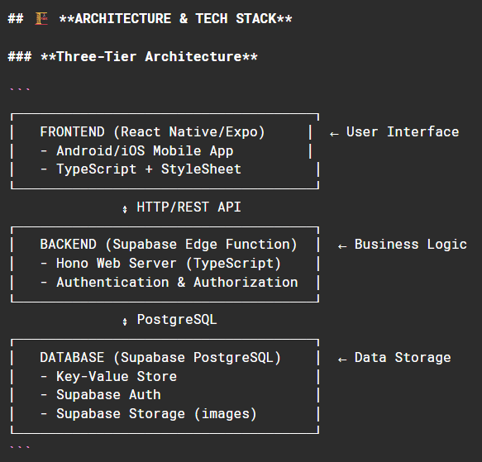
Authentication System
User authentication implements Supabase Auth with secure session management and token-based API authorization. The system maintains session persistence across application restarts while ensuring secure credential handling. Password policies enforce minimum security standards without creating excessive user friction.
API Integration
The frontend-backend communication utilizes a dedicated API service layer that centralizes request handling, authentication token management, and error processing. This abstraction simplifies component logic while ensuring consistent error handling and user feedback throughout the application interface.

14. Appendix D: API Endpoint Documentation
Authentication Endpoints
- POST /auth/signup - User registration
  - Parameters: name, email, password, location
  - Response: user object, session token
- POST /auth/signin - User authentication
  - Parameters: email, password
  - Response: user object, session token
- GET /auth/session - Session validation
  - Headers: Authorization token
  - Response: user object
Item Management Endpoints
- GET /items - Retrieve all food items
  - Parameters: optional filters (category, dietary)
  - Response: array of item objects
- POST /items - Create new food item
  - Headers: Authorization token
  - Parameters: item data object
  - Response: created item object
- PATCH /items/:id - Update existing item
  - Headers: Authorization token
  - Parameters: updated item data
  - Response: updated item object
- DELETE /items/:id - Remove food item
  - Headers: Authorization token
  - Response: success confirmation
User Management Endpoints
- GET /profile/:userId - Retrieve user profile
  - Response: user profile object with statistics
- PATCH /profile - Update user profile
  - Headers: Authorization token
  - Parameters: updated profile data
  - Response: updated profile object
Review System Endpoints
- GET /reviews/:userId - Retrieve user reviews
  - Response: array of review objects
- POST /reviews - Submit new review
  - Headers: Authorization token
  - Parameters: review data object
  - Response: created review object
Messaging Endpoints
- GET /messages/:itemId - Retrieve conversation history
  - Headers: Authorization token
  - Response: array of message objects
- POST /messages - Send new message
  - Headers: Authorization token
  - Parameters: message content, recipient, item
  - Response: sent message object
- POST /messages/mark-read - Update read status
  - Headers: Authorization token
  - Parameters: itemId, senderId
  - Response: success confirmation
Administrative Endpoints
- GET /users - Retrieve all users (admin only)
  - Headers: Authorization token
  - Response: array of user objects
- DELETE /users/:userId - Remove user account (admin only)
  - Headers: Authorization token
  - Response: deletion summary

15. Appendix E: Code Explanation
This appendix provides detailed explanations of key code components in the Fooditude application, demonstrating the technical implementation of core features.
E.1 Authentication System (LoginPage.tsx)
The authentication system implements a secure, user-friendly login and registration interface:
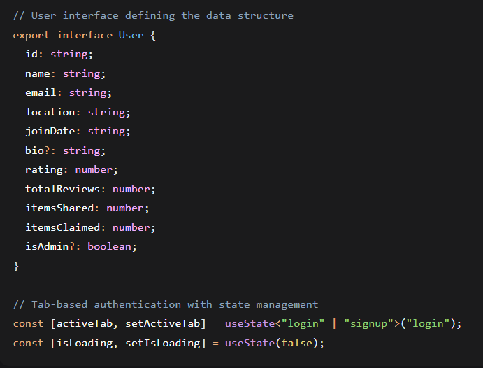
Key Features:
- Tab-based Interface: Users can seamlessly switch between login and registration
- Form Validation: Client-side validation ensures all required fields are completed
- Secure Authentication: Integration with Supabase Auth with proper error handling
- Automatic Session Management: Successful signup triggers automatic login
- Loading States: Visual feedback during API calls prevents duplicate submissions
The component uses React Native's KeyboardAvoidingView to ensure form fields remain visible when the virtual keyboard is active, enhancing mobile user experience.
E.2 Food Item Display Component (ItemCard.tsx)
The ItemCard component renders individual food items with intelligent expiry date handling:
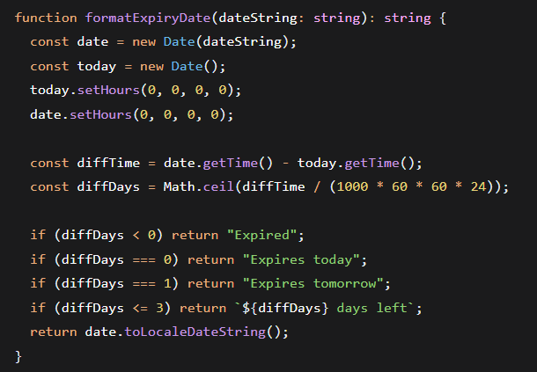
Visual Indicators:
- Urgent Badge: Red indicator for items expiring within 3 days
- Reserved Badge: Secondary color badge for claimed items
- Dietary Tags: Horizontal scroll of dietary restrictions/preferences
- Optimized Images: Aspect ratio consistency (4:3) across all items
The component uses useMemo hooks to optimize performance by caching expensive calculations like expiry date formatting and urgency detection.

E.3 Profile Management System (ProfilePage.tsx)
The profile system displays user information, reviews, and includes app feedback functionality:
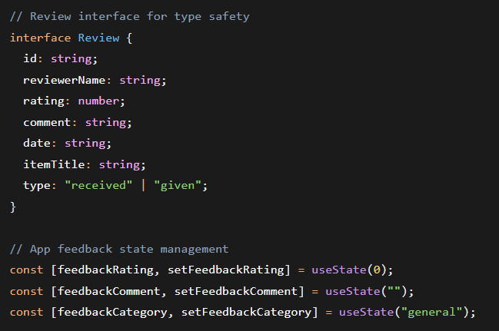
Profile Features:
- Avatar Generation: Dynamic initials-based avatars with theme-appropriate colors
- Statistics Display: Items shared/claimed with visual icons
- Review Aggregation: Average rating calculation and review count
- Bio Section: Optional user biography with proper spacing
App Feedback System:
- Star Rating: Interactive 5-star rating system
- Category Selection: Four feedback categories (general, bug, feature, UI/UX)
- Form Validation: Required fields with user-friendly error messages
- Submission Handling: Loading states and success/error feedback

E.4 API Service Layer (api.ts)
The centralized API service manages all backend communications with robust error handling:
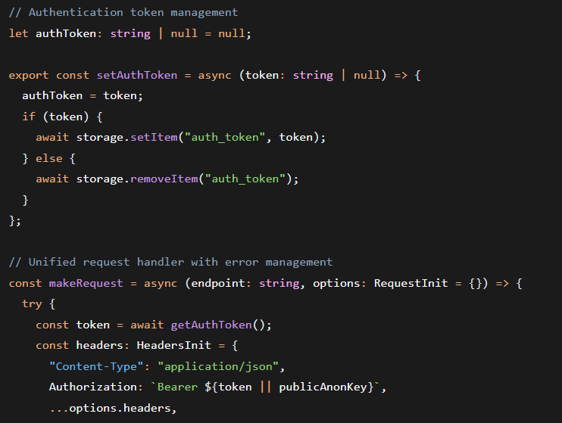
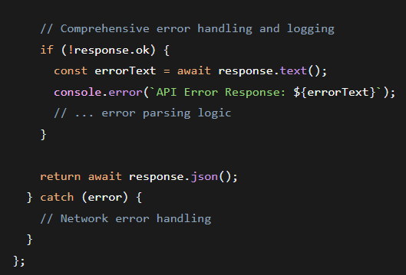
API Modules:
- Authentication: Signup, login, session management
- Items: CRUD operations for food listings
- Reviews: User rating and feedback system
- Messages: Real-time communication between users
- Admin: User management and analytics
- Image Upload: Mobile-optimized file uploads

E.5 Main Application Architecture (App.tsx)
The main application component orchestrates all features with comprehensive state management:
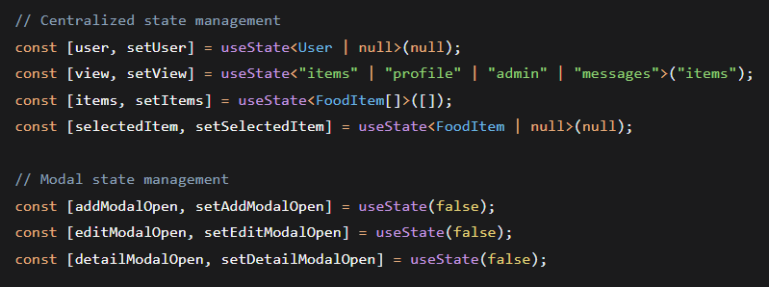
Key Architectural Patterns:
- Theme Provider: Consistent theming across all components
- Modal Management: Coordinated modal visibility states
- Filter System: Multi-criteria item filtering (search, category, dietary, ownership)
- Refresh Control: Pull-to-refresh functionality for item lists
- Navigation Flow: Seamless transitions between different application views

E.6 Admin Panel System (AdminPanel.tsx)
The admin interface provides comprehensive platform management capabilities:
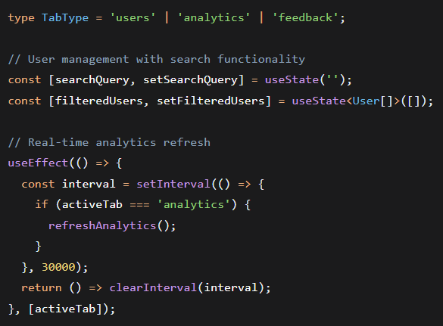
Admin Features:
- Role-Based Access: Admin-only functionality with permission checks
- User Management: Search, view, and delete user accounts with cascading data removal
- Analytics Dashboard: Real-time platform statistics with auto-refresh
- Safety Measures: Prevention of self-deletion and comprehensive confirmation dialogs

E.7 Design System and Theming
The application uses a centralized design system defined in theme.ts:
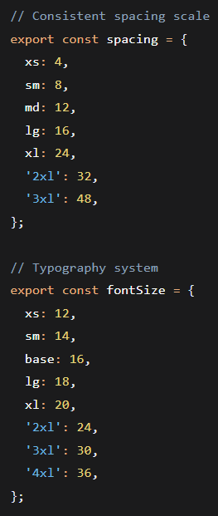
Benefits of this approach:
- Consistency: Uniform spacing, colors, and typography across all components
- Maintainability: Centralized design tokens enable quick global changes
- Accessibility: Proper color contrast ratios and readable font sizes
- Theme Support: Dark/light mode capability through theme context
E.8 Technical Implementation Highlights
Performance Optimizations:
- Memoization of expensive calculations using useMemo
- Efficient re-rendering through proper dependency arrays
- Debounced search functionality to reduce API calls
- Image optimization with consistent aspect ratios
Error Handling:
- Comprehensive API error parsing and user-friendly messages
- Network failure detection and recovery mechanisms
- Form validation with clear user guidance
- Loading states for all asynchronous operations
Type Safety:
- Comprehensive TypeScript interfaces for all data structures
- Strict type checking throughout the codebase
- Self-documenting code through type definitions
- Compile-time error detection

